

**B.P.H.E SOCIETY’S**

**AHMEDNAGAR COLLEGE AHMEDNAGAR**

**A project on**

**“Sports management system”**

**Department of computer science**

**Submitted in partial fulfillment of the requirement of the degree**

**BBA (CA)**

**Submitted by:**

**Vishal mahadev ghorpade**

**Yash ravindra sharma**

**Dr. Sayyad Razak**

**Head of the department**

**Alia Pathan**

**project guide**

Certified that this is a bonafide record of the project work titled

**“SPORTS MANAGEMENT SYSTEM”**

**Done by :**

* **Vishal Mahadev Ghorpade**
* **Yash Ravindra Sharma**

Of IV semester BBA(CA) in the year 2023 in partial fulfilment of the requirement for the award of degree of bachelor of business administration(computer application)

CERTIFICATE

Abstract

The **SPORTS MANAGEMENT SYSTEM objective is to provide a platform to manage the activity of many sports at a time.**

**It will also manage the selection activity of student to college and to state level competition. The project will help the student to get register from anywhere and anytime**

**The idea of this project is derived from the following existing sports management system in which student are not able to get proper information about the games conducted in various college of university .**

**They are only aware of the information provided by their college.**

Topic

1**. Introduction**

* + - Motivation
    - Problem Statement
    - Purpose
    - Literature survey

**2. Requirement Analysis**

* Software requirement
* Hardware requirement

**3. METHODOLOGY**

* Algorithm used
* Project Flow

**4: RESULT AND DISCUSSION**

* Questionnaire survey analysis
* Use case diagram
* Class diagram
* data flow chart
* entity relationship diagram
* context diagram
* database design
* Screenshot of project
* Test plan

**5: CONCLUSION& RECOMMANDATION**

**6. REFERENCES**

Ch1

**Introduction to system**

In this system user manage various game, tournament, schedule, booking request, news and team. Customer can register and log in to system view team customer can register and login to system .view teams, tournament schedule and request for booking. Guest user view tournament, schedule and registration for tournament.

Sport management system in the process of storing whereby records of member are directly stored by the admin interactively in real –time without an immediacy services

Sports management is the process of storing member’s details who have taken admission to the particular sport

**Motivation:**

* To provide information and manage the system regarding sport event of the game tournaments

**Problem statement**

* The problem of planning organization, time management, on proper use of resources, budget, allocation of resources and space management

**Purpose**

* The sport management system provides the user with a dashboard that they can use to complete their daily tasks and functions related to managing team, scheduling tournaments etc.

Ch : 2

**Requirement Analysis**

* + software requirement
  + Hardware requirement

**Introduction**

In this chapter we mentioned the software and hardware requirement, which are necessary for successfully running this system. The major element in building systems is selecting compatible hardware and software. The system analyst has to determine what software package is best for the sports management and where software is not an issue

**Software requirements**:

* Microsoft windows- 7/8/10 or Linux.
* VScode (or any other compatible code/text editor)
* Chrome or any other browser.
* File system to store data/files.

**Hardware requirements**:

* Intel/AMD processor above 2.0 GHz
* 2 GB RAM or more.
* 160GB or more hard disk drive or above.

Ch: 3

**METHODOLOGY**

* + Coding
  + How it works

1. **Code for setting up navigation bar for easily finding work areas**

 <nav id="navbar">

        <div id="logo">

<img src="img/logo1.jpg" alt="sportscentric.com">

        </div>

<ul>

            <li class="item"><a href="#home">Home</a></li>

            <li class="item"><a href="#servicescontainer">Services</a></li>

            <li class="item"><a href="#client-section">Our Clients</a></li>

            <li class="item"><a href="#contact">Contact Us</a></li>

        </ul>

    </nav>

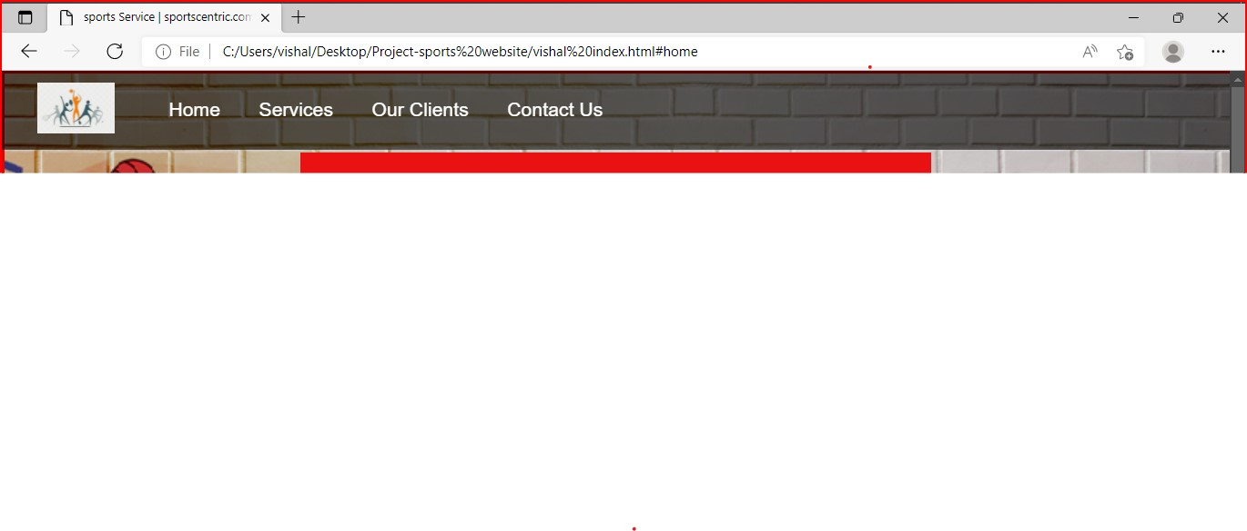

**2. Code for setting up login and home page as website intro**

    <section id="home">

        <h1 class="h-primary">Welcome to sportscentric</h1>

        <p>website devlope for sports users which manage </p>

                     <p> various game, tournament, tutorials , performance etc. </p>

        <button class="btn">login Now</button>

    </section>

/* Home Section */

#home{

    display: flex;

    flex-direction: column;

    padding:3px 50px;

    height: 550px;

    justify-content: right;

    align-items: center;

}

}

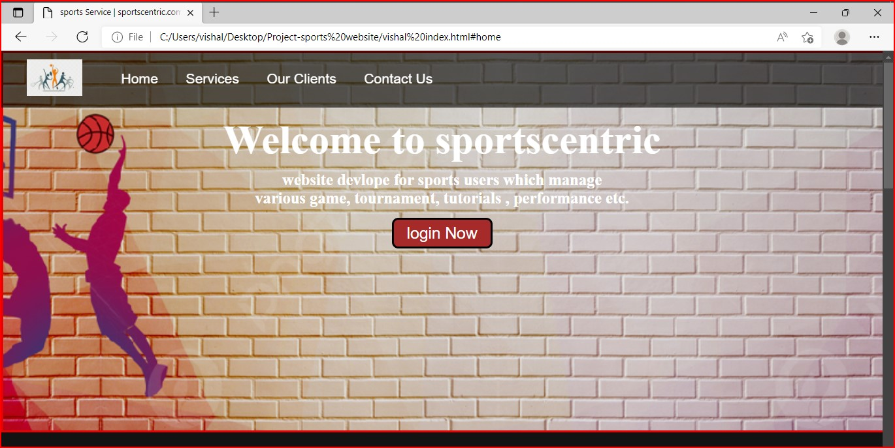

1. **Code for services provided by website**

    <section id="services-container">

        <h1 class="h-primary center">your game</h1>

        <div id="services">

            <div class="box">

                <img src="img/volly1.jpg" alt="">

                <h2 class="h-secondary center">vollyball</h2>

                <p class="center">Volleyball is a team sport in which two teams of six players are separated by a net.

                     Each team tries

                     to score points by grounding a ball on the other team's court under organized rules.</p>

                <button class="btn2"> next </button>

            </div>

            <div class="box">

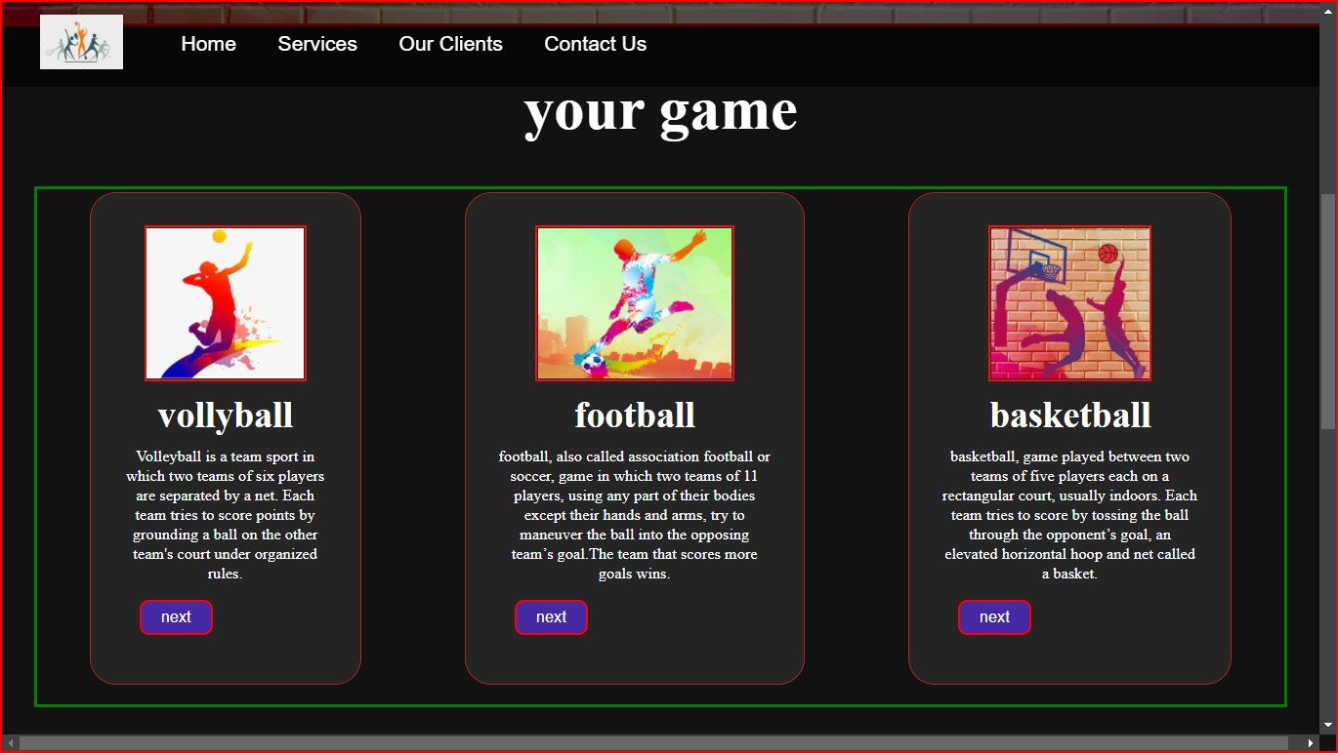

1. **Code for clients in a website**

    <section id="client-section">

        <h1 class="h-primary center">Our Clients</h1>

        <div id="clients">

            <div class="client-item">

                <img src="img/applelogo1.png" alt="Our Client">

            </div>

            <div class="client-item">

                <img src="img/hplogo.png" alt="Our Client">

            </div>

            <div class="client-item">

                <img src="img/micrologo.png" alt="Our Client">

            </div>

            <div class="client-item">

                <img src="img/skypelogo.png" alt="Our Client">

            </div>

        </div>

    </section>

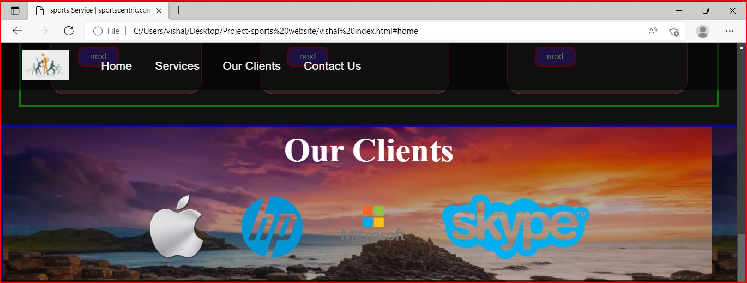

    <section id="contact">

* **Code for clients in a website**

        <h1 class="h-primary center">Contact Us</h1>

        <div id="contact-box">

            <form action="">

                <div class="form-group">

                    <label for="name">Name: </label>

                    <input type="text" name="name" id="name" placeholder="Enter your name">

                </div>

                <div class="form-group">

                    <label for="email">Email: </label>

                    <input type="email" name="name" id="email" placeholder="Enter your email">

</div>

                <div class="form-group">

                    <label for="message">Message: </label>

                    <textarea name="message" id="message" cols="30" rows="10"></textarea>

                </div>

            </form>

        </div>

    </section>

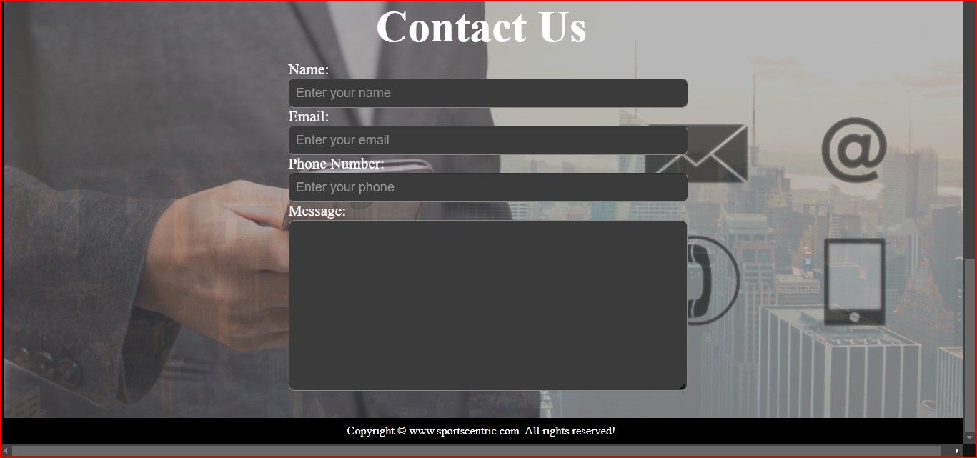

Ch: 4

**Use case diagram: admin/organizer**

**Admin dashboard**

**Manage player**

**Manage schedule**

**Admin login**

**Admin**

**Manage user (view/delete**

**Manage team**

**Manage Tournaments**

**Use case diagram user:**

**User profile update**

**Change password**

**View team**

**User login**

**User**

**View player**

**View schedule**

**data flow chart**

Tournament manage

Zero level DFD-sports management

Player management

Services management

System user management

Login management

**First**

**Er diagram**

Tournament report

Services report

Generate system user report

Check user login details

Generate player report

Login management

Player management

System user management

Tournament manage

Services management

First level DFD-sports management

**s**

ER diagram sports management

Game

Plays

Participate

Injury records

Logs

Players

Has

Team

**Ch: 5**

**CONCLUSION**

Sports management system is not only rewarding but it also helps the user /admin to quickly organize the sport event and lists in short interval of time .I personally see this as a great way to find even more informative for my topic .it will be able to check anything related to sports at any time .paper work and manual work is reduced through this system .the system is user friendly and easy to use

I hope user not only enjoy this system, but also get satisfaction from finding how each and every feature of sport website is implemented.

Ch: 6

**REFERENCES**

* [**www.youtube.com**](http://www.youtube.com)
* [**www.slideshare.com**](http://www.slideshare.com)
* [**www.pngtree.com**](http://www.pngtree.com)
* [**https://Yctacadmy.blogspot.com**](https://Yctacadmy.blogspot.com)